2.22: a) The acceleration is found from Eq. (2.13), which 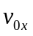= 0;

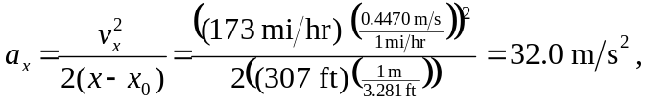

where the conversions are from Appendix E.

b) The time can be found from the above acceleration,

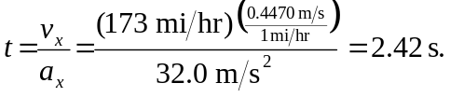

The intermediate calculation may be avoided by using Eq. (2.14), again with v_{0x} = 0,

